EXERCISE NO.1

QUES-1CREATE A SIMPLE HTML USING BASICS TAGS?

CODE:

<!DOCTYPE html>

<html>

<head>

<title>Simple HTML Page</title>

</head>

<body>

<h1>Welcome to My First HTML Page</h1>

<p>This is a simple HTML page with basic tags.</p>

</body>

</html>

OUTPUT:

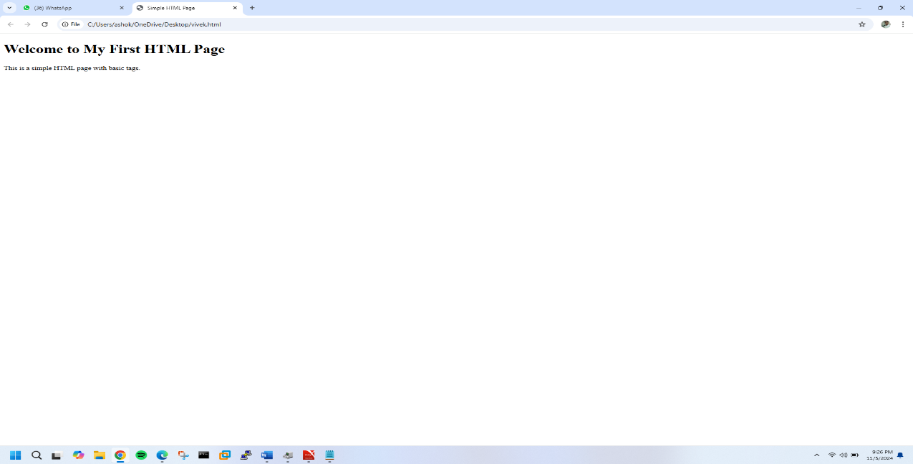

EXERCISE NO.2

QUES-2CREATE A WEB PAGE THAT DISLPAY OUR NAME TO THE SCREEN?

CODE:

<!DOCTYPE html>

<html>

<head>

<title>My Name</title>

</head>

<body>

<h1>My Name is [Vivek]</h1>

</body>

</html>

OUTPUT: 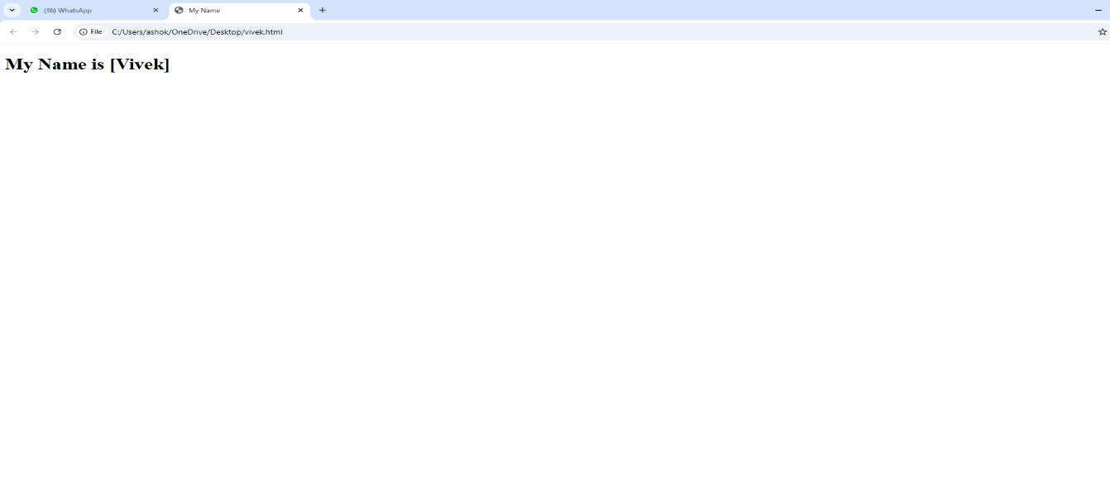

EXERCISE NO.3

QUES-3 CREATE A WEB PAGE AND SHOW THE OUTPUT FROM 1TO10 IN

SEPERATE LINES?

CODE:

<!DOCTYPE html>

<html>

<head>

<title>Numbers 1-10</title>

</head>

<body>

<h1>Numbers from 1 to 10:</h1>

<p>1</p>

<p>2</p>

<p>3</p>

<p>4</p>

<p>5</p>

<p>6</p>

<p>7</p>

<p>8</p>

<p>9</p>

<p>10</p>

</body>

</html>

OUTPUT:

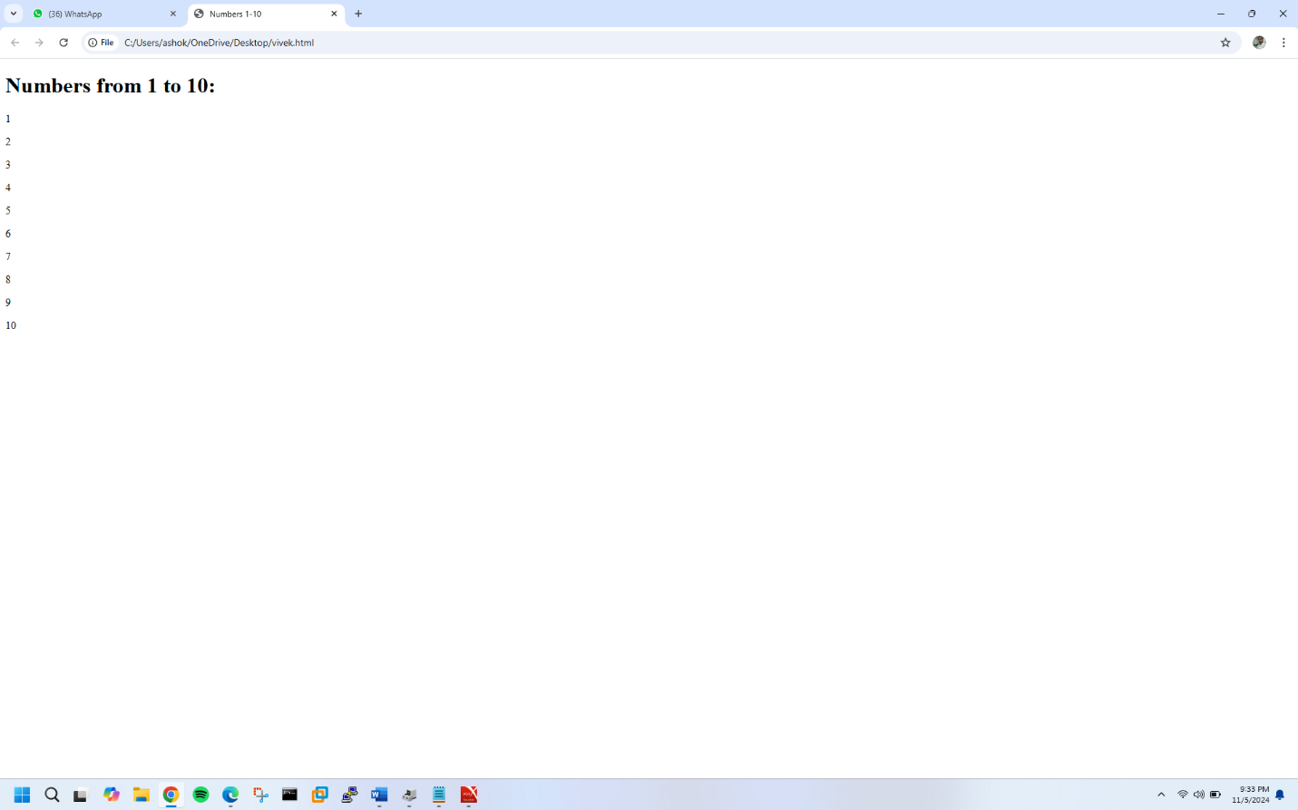

EXERCISE NO.4

QUES-4 CREATE A WEB PAGE AND SHOW THE OUTPUT FROM1 TO 10IN

SEPERATE LINES,EACH NO.BEING IN DIFFERENT COLOUR?

CODE:

<!DOCTYPE html>

<html lang="en">

<head>

<meta charset="UTF-8">

<meta name="viewport" content="width=device-width, initial-scale=1.0">

<title>Colored Numbers</title>

<style>

.number1 { color: red; }

.number2 { color: blue; }

.number3 { color: green; }

.number4 { color: orange; }

.number5 { color: purple; }

.number6 { color: pink; }

.number7 { color: brown; }

.number8 { color: teal; }

.number9 { color: navy; }

.number10 { color: gold; }

</style>

</head>

<body>

<div class="number1">1</div>

<div class="number2">2</div>

<div class="number3">3</div>

<div class="number4">4</div>

<div class="number5">5</div>

<div class="number6">6</div>

<div class="number7">7</div>

<div class="number8">8</div>

<div class="number9">9</div>

<div class="number10">10</div>

</body>

</html>

OUTPUT:

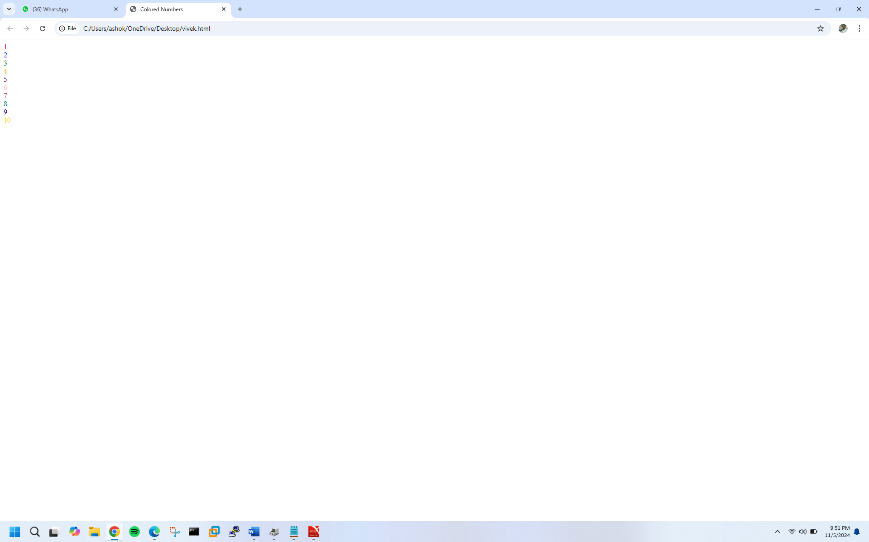

EXERCISE NO.5

QUES-5 HOW DO I MAKE A PICTURE AS BACKGROUND ON MY WEB PAGE?

CODE:

<html>

<head>

<title>Background Image Example</title>

</head>

<body>/

<img

src="https://cdni.autocarindia.com/Utils/ImageResizer.ashx?n=https://cdni.autocarindia.com/ExtraIm

ages/20230426025856_DEF_24MY_130_V8_260423_01.jpg&w=700&c=1">

<h1>Welcome to My Web Page</h1>

<p>This page has a background image.</p>

</body>

</html>

OUTPUT:

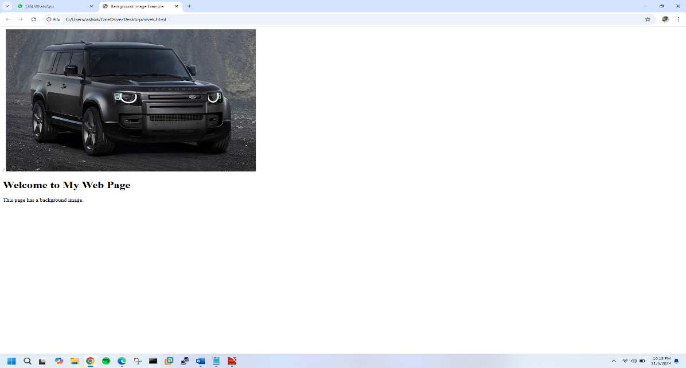

EXERCISE NO.6

QUES-6 CREATE A WEB PAGE TO PRINT A PARAGRAPH ITH4-5

SENTENCES,EACH SENTENCE SHALL HAVE A DIFFERENT FONT?

CODE:

<!DOCTYPE html>

<html>

<head>

<title>Multi-Font Paragraph</title>

<style>

.sentence1 { font-family: Arial; color: blue; }

.sentence2 { font-family: Comic Sans MS; color: green; }

.sentence3 { font-family: Courier New; color: red; }

.sentence4 { font-family: Georgia; color: purple; }

.sentence5 { font-family: Impact; color: orange; }

</style>

</head>

<body>

<h1>Multi-Font Paragraph</h1>

<p>

<span class="sentence1">This is the first sentence in Arial font.</span>

<span class="sentence2">This is the second sentence in Comic Sans MS font.</span>

<span class="sentence3">This is the third sentence in Courier New font.</span>

<span class="sentence4">This is the fourth sentence in Georgia font.</span>

<span class="sentence5">This is the fifth sentence in Impact font.</span>

</p>

</body>

</html>

OUTPUT:

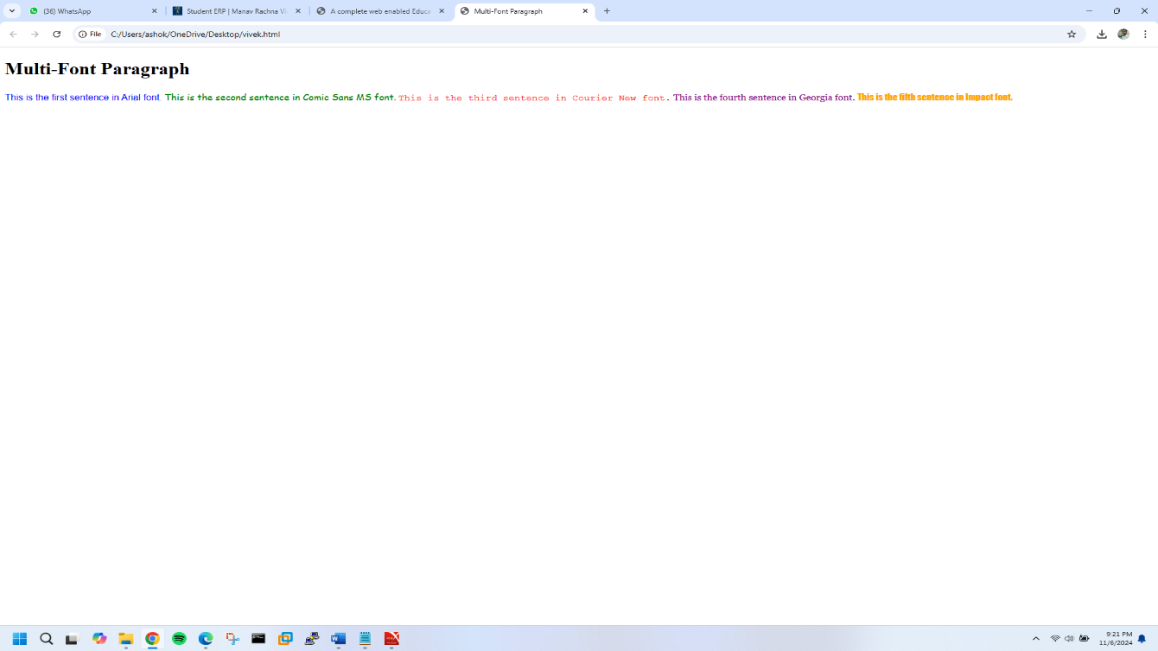

EXERCISE NO.7

QUES-7 WRITE HTML CODE TO PRINT A PARAGRAPH THAT IS DESCRIPTION

OF A BOOK ,IT SHALL INCLUDE THEE TITLE OF THE BOOK,ITS AUTHOR

NAME;NAME AND TITLE SHOULD BE UNDERLINED AND ALL ADJECTIVES

SHALL BE BOLD AND ITALICS?

CODE:

<html>

<head>

<title>Book Description</title>

</head>

<body>

<h1>Book Description</h1>

<p>

<u><strong>The Great Gatsby</strong></u> is a <strong><em>captivating</em></strong> novel

written by

<u><strong>F. Scott Fitzgerald</strong></u>. It tells the story of the

<strong><em>mysterious</em></strong>

Jay Gatsby and his <strong><em>incredible</em></strong> love for Daisy Buchanan, set against

the backdrop

of the <strong><em>glamorous</em></strong> 1920s. The book explores themes of

<strong><em>wealth</em></strong>,

<strong><em>love</em></strong>, and the <strong><em>American</em></strong> dream,

making it a

<strong><em>timeless</em></strong> classic that continues to resonate with readers today.

</p>

</body>

</html>

OUTPUT:

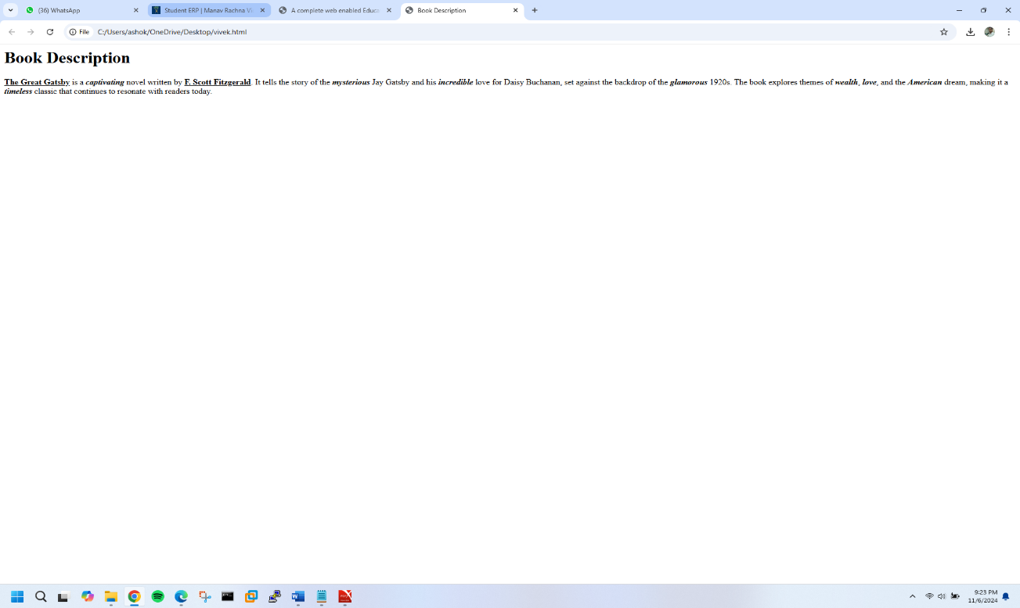

EXERCISE NO.8

QUES-8 WRITE HTML TO PRINT YOUR NAME USING HEADING TAGS,EVERY

LETTER SHOULD HAVE BE OF DIFFERENT SIZE?

CODE:

<!DOCTYPE html>

<html>

<head>

<title>Variable Font Size Name</title>

</head>

<body>

<h1>

<span style="font-size: 24px;">S</span>

<span style="font-size: 30px;">H</span>

<span style="font-size: 36px;">U</span>

<span style="font-size: 42px;">B</span>

<span style="font-size: 48px;">H</span>

</h1>

<h2>

<span style="font-size: 40px;">M</span>

<span style="font-size: 34px;">I</span>

<span style="font-size: 44px;">T</span>

<span style="font-size: 38px;">T</span>

<span style="font-size: 38px;">A</span>

<span style="font-size: 41px;">L</span> </h2>

</body>

</html>

OUTPUT:

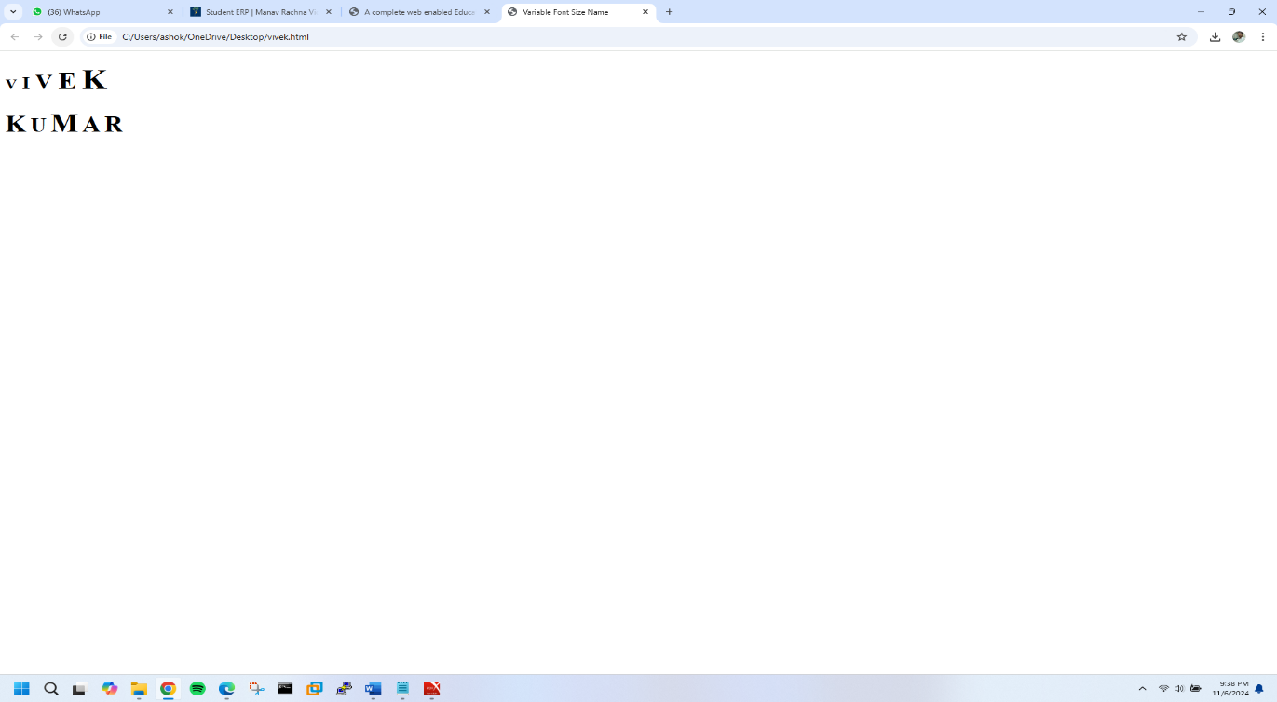

EXERCISE NO.9

QUES-9 WRITE HTML CODE TO PRINT THE SEQUENCE OF NUMBER1-

20.EACH NO SHALL BE IN DIFFERENT LINE WITH NUMBER 2NEXT TO IT AS

SUBSCIPT,AN EQUAL SIGN AND THE RRESULT?

CODE

<!DOCTYPE html>

<html>

<head>

<title>Number Sequence</title>

</head>

<body>

<h1>Number Sequence 1-20</h1>

<p>

<!-- Numbers 1-20 with subscript 2 and calculation -->

1<sub>2</sub> = 1<br>

2<sub>2</sub> = 4<br>

3<sub>2</sub> = 9<br>

4<sub>2</sub> = 16<br>

5<sub>2</sub> = 25<br>

6<sub>2</sub> = 36<br>

7<sub>2</sub> = 49<br>

8<sub>2</sub> = 64<br>

9<sub>2</sub> = 81<br>

10<sub>2</sub> = 100<br>

11<sub>2</sub> = 121<br>

12<sub>2</sub> = 144<br>

13<sub>2</sub> = 169<br>

14<sub>2</sub> = 196<br>

15<sub>2</sub> = 225<br>

16<sub>2</sub> = 256<br>

17<sub>2</sub> = 289<br>

18<sub>2</sub> = 324<br>

19<sub>2</sub> = 361<br>

20<sub>2</sub> = 400<br>

</p>

</body>

</html>

OUTPUT:

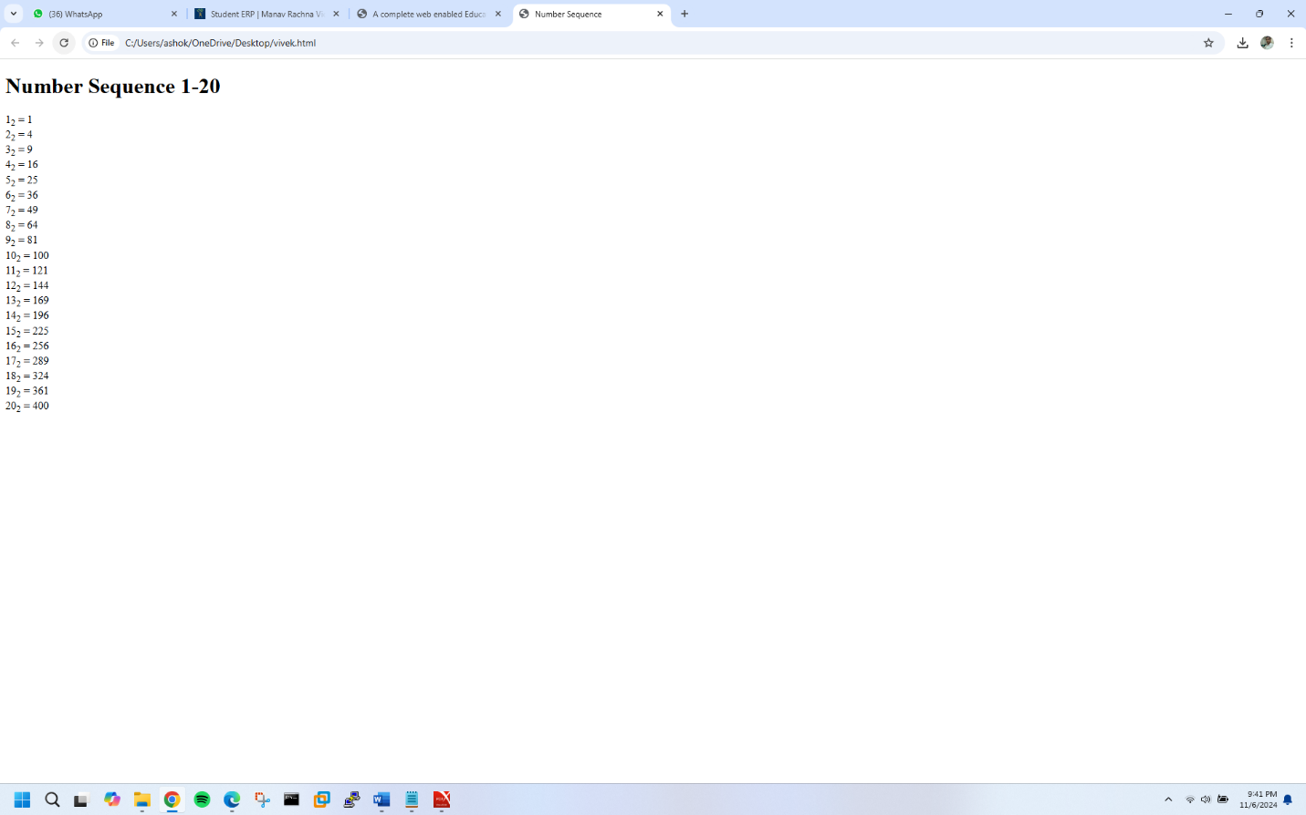

EXERCISE NO.10

QUES-10 WRITE HTML CODE TO DISPLAY AN IMAGE WITH BORDER OF

SIZE WITH WIDTH200,HEIGHT200 PIXELS,LEAVING HSPACE AND VSPACE

OF YOUR CHOICE WITH IMAGE HANGING IN THE RIGHT SIDE ON THE

SCREEN?

CODE:

<!DOCTYPE html>

<html>

<head>

<title>Image Display</title>

</head>

<body>

<img src="image.jpg"

alt="Example Image"

width="200"

height="200"

border="2"

hspace="10"

vspace="10"

align="right">

</body>

</html>

OUTPUT:

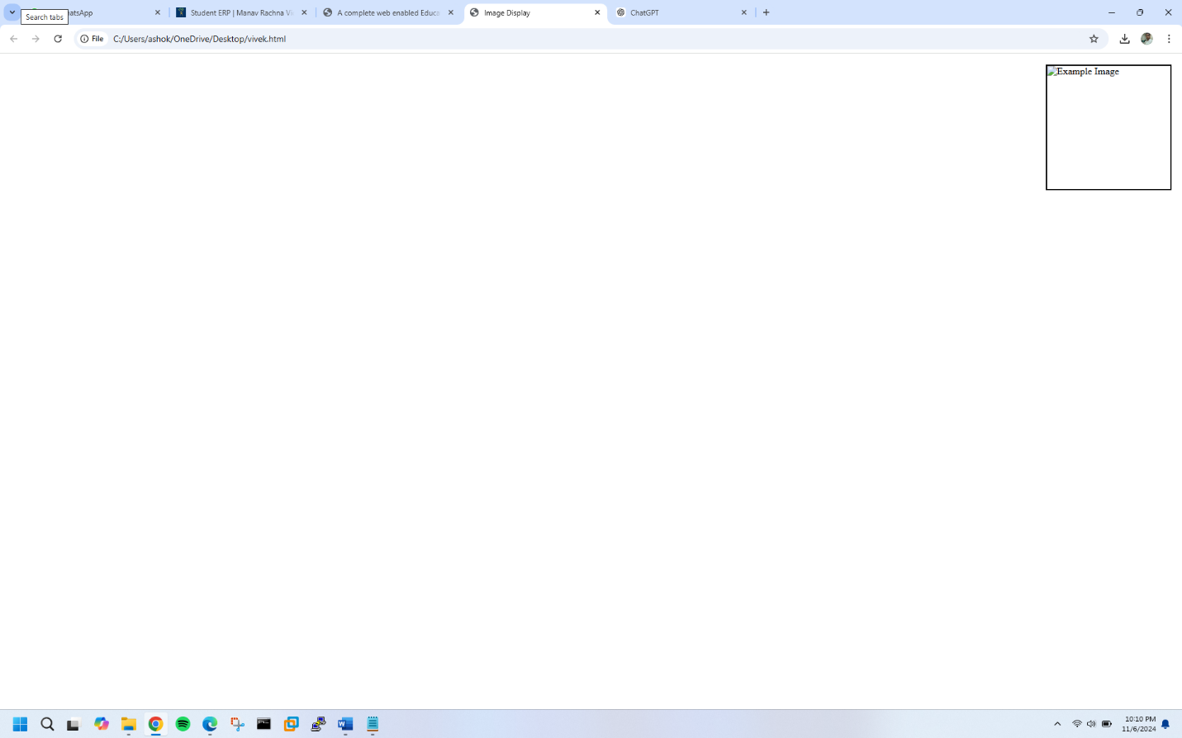

**EXERCISE NO.11**

**QUES-11 WRITE HTML CODE TO CREATE A WEB PAGE WITH HEADING. THE HEADING SHALL BE DISPLAYED AT THE TOP-CENTER OF THR PAGE AND THE IMAGE SHALL AT THE CENTRE,JUST BELO THE HEADING?**

**CODE:**

<!DOCTYPE html>

<html>

<head>

<title>Centered Heading and Image</title>

<style>

body {

margin: 0;

padding: 0;

background-color: #f2f2f2;

}

.container {

text-align: center;

padding-top: 50px;

}

.image-container {

margin-top: 50px;

}

.image-container img {

width: 50%;

height: auto;

border-radius: 10px;

box-shadow: 0 0 10px rgba(0, 0, 0, 0.2);

}

</style>

</head>

<body>

<div class="container">

<h1>Centered Heading</h1>

<div class="image-container">

<img src=" C:\Users\ashok\OneDrive\Pictures\Screenshots 2024-11-06 221503 ="Centered Image">

</div>

</div>

</body>

</html>

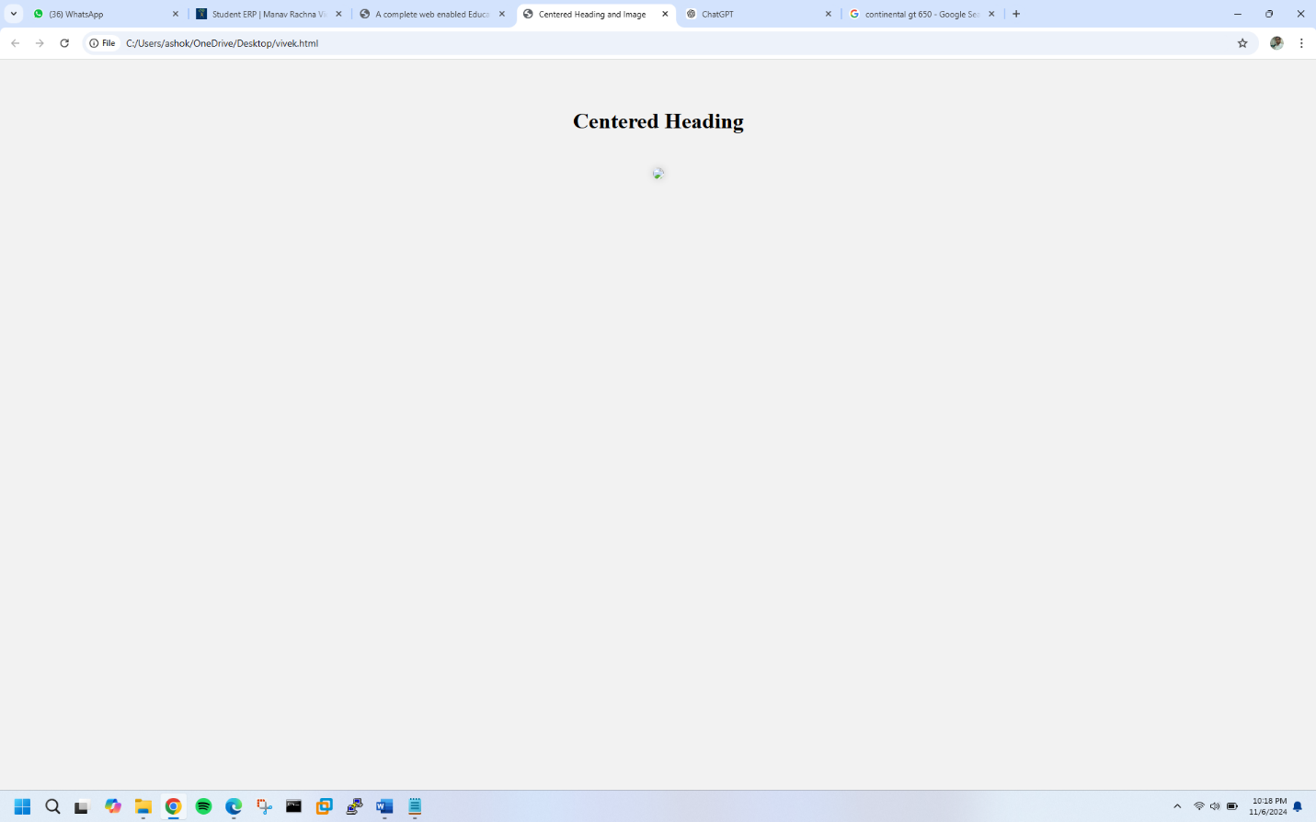

**EXERCISE NO.12**

QUES-12 WRITE HTML CODE USING MULTIMEDIA TAGS?

**CODE:**

**<!DOCTYPE html>**

**<html>**

**<head>**

**<title>Multimedia Tags</title>**

**<style>**

**body {**

**font-family: Arial, sans-serif;**

**}**

**</style>**

**</head>**

**<body>**

**<h1>Multimedia Tags</h1>**

**<!-- Audio Tag -->**

**<h2>Audio</h2>**

**<audio controls>**

**<source src="audio.mp3" type="audio/mp3">**

**Your browser does not support the audio tag.**

**</audio>**

**<!-- Video Tag -->**

**<h2>Video</h2>**

**<video width="500" height="300" controls>**

**<source src="video.mp4" type="video/mp4">**

**Your browser does not support the video tag.**

**</video>**

**<!-- Image Tag -->**

**<h2>Image</h2>**

**<img src="image.jpg" alt="Multimedia Image" width="500" height="300">**

**<!-- Embed Tag (for YouTube video) -->**

**<h2>Embedded YouTube Video</h2>**

**<embed src="(link unavailable)" width="500" height="300">**

**<!-- Object Tag (for Flash content) -->**

**<h2>Flash Content</h2>**

**<object data="flash.swf" width="500" height="300">**

**<param name="movie" value="flash.swf">**

**Your browser does not support Flash.**

**</object>**

**</body>**

**</html>**

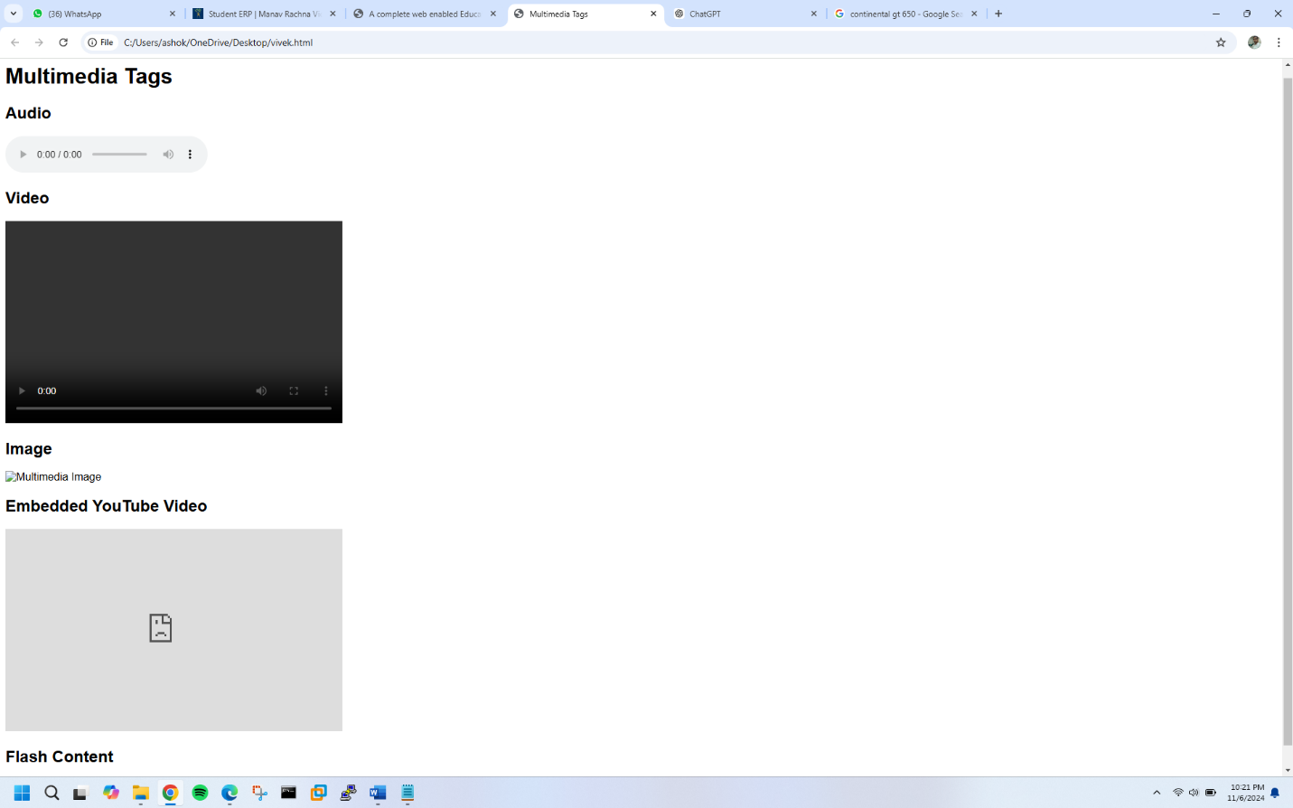

**EXERCISE NO.13**

**QUES-13 CREATE A TABLE USING COLSPAN AND ROWSPAN TAKING EXAMPLE OF STUDENT RECORD?**

**CODE:**

**<!DOCTYPE html>**

**<html>**

**<head>**

**<title>Student Records</title>**

**<style>**

**table {**

**border-collapse: collapse;**

**}**

**th, td {**

**border: 1px solid #ddd;**

**padding: 10px;**

**text-align: center;**

**}**

**th {**

**background-color: #f0f0f0;**

**}**

**</style>**

**</head>**

**<body>**

**<h1>Student Records</h1>**

**<table>**

**<tr>**

**<th colspan="5">Student Information</th>**

**</tr>**

**<tr>**

**<th>Student ID</th>**

**<th>Name</th>**

**<th>Grade</th>**

**<th>Subjects</th>**

**<th>Average Score</th>**

**</tr>**

**<tr>**

**<td>001</td>**

**<td>John Doe</td>**

**<td>10th</td>**

**<td rowspan="3">**

**English<br>**

**Mathematics<br>**

**Science**

**</td>**

**<td>85%</td>**

**</tr>**

**<tr>**

**<td>002</td>**

**<td>Jane Smith</td>**

**<td>10th</td>**

**<td>90%</td>**

**</tr>**

**<tr>**

**<td>003</td>**

**<td>Bob Johnson</td>**

**<td>10th</td>**

**<td>88%</td>**

**</tr>**

**<tr>**

**<th colspan="5">Total</th>**

**</tr>**

**<tr>**

**<td colspan="4">Average Score:</td>**

**<td>87.67%</td>**

**</tr>**

**</table>**

**</body>**

**</html>**

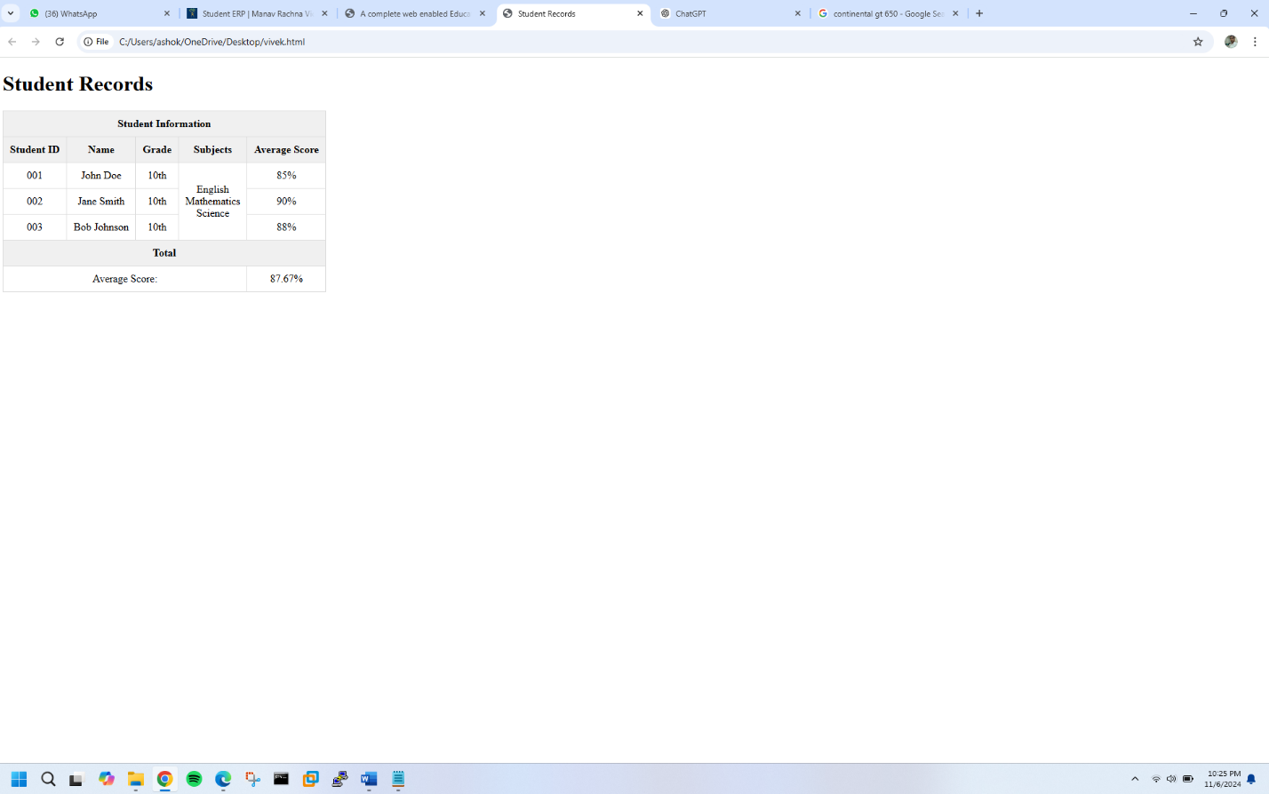

**EXERCISE NO.14**

**QUES-14 WRITE HTML CODE USING TABLE TAG<TABLE> AN CELLPADDING AND CELLSPACING AS ITS ATTRIBUTES?**

**CODE:**

**<!DOCTYPE html>**

**<html>**

**<head>**

**<title>Table Example</title>**

**</head>**

**<body>**

**<h1>Table Example</h1>**

**<table cellpadding="10" cellspacing="5" border="1">**

**<tr>**

**<th>Header 1</th>**

**<th>Header 2</th>**

**<th>Header 3</th>**

**</tr>**

**<tr>**

**<td>Cell 1</td>**

**<td>Cell 2</td>**

**<td>Cell 3</td>**

**</tr>**

**<tr>**

**<td>Cell 4</td>**

**<td>Cell 5</td>**

**<td>Cell 6</td>**

**</tr>**

**</table>**

**</body>**

**</html>**

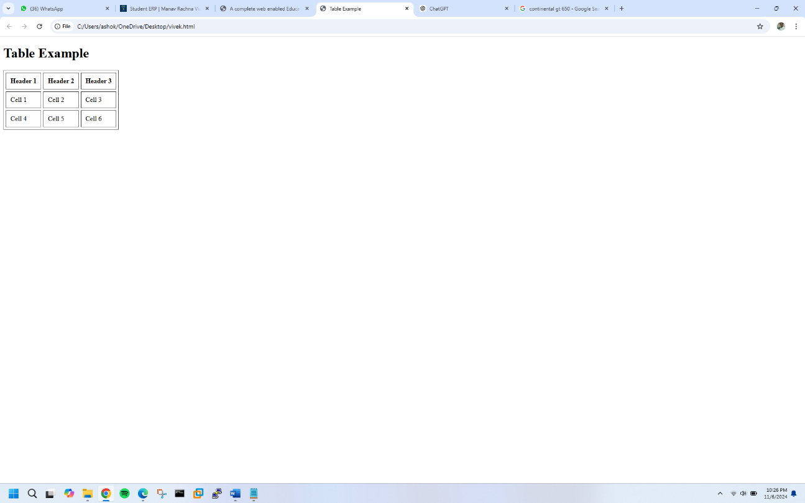

**EXERCISE NO.15**

**QUES-15 CREATE ORDERED, UNORDERED AND DEFINATION LISTS TAKING EXAMPLE OF YOUR SUBJECTS IN MCA IST, ||ND AND |||SEMSESTER?**

**CODE:**

**<!DOCTYPE html>**

**<html>**

**<head>**

**<title>MCA Subjects</title>**

**</head>**

**<body>**

**<h1>MCA 1st Semester (Ordered List)</h1>**

**<ol>**

**<li>Programming Fundamentals (PF)</li>**

**<li>Data Structures (DS)</li>**

**<li>Computer Organization (CO)</li>**

**<li>Discrete Mathematics (DM)</li>**

**<li>Software Engineering (SE)</li>**

**<li>Web Technologies (WT)</li>**

**</ol>**

**<h1>MCA 2nd Semester (Unordered List)</h1>**

**<ul>**

**<li>Object-Oriented Programming (OOP)</li>**

**<li>Database Management Systems (DBMS)</li>**

**<li>Operating Systems (OS)</li>**

**<li>Computer Networks (CN)</li>**

**<li>Cyber Security (CS)</li>**

**<li>Data Mining (DM)</li>**

**</ul>**

**<h1>MCA 3rd Semester (Definition List)</h1>**

**<dl>**

**<dt>Elective Subjects:</dt>**

**<dd>Artificial Intelligence (AI): Study of intelligent agents and their applications.</dd>**

**<dd>Machine Learning (ML): Study of algorithms that enable machines to learn from data.</dd>**

**<dd>Data Analytics (DA): Study of methods for extracting insights from data.</dd>**

**<dt>Core Subjects:</dt>**

**<dd>Advanced Computer Architecture (ACA): Study of advanced computer architecture concepts.</dd>**

**<dd>Human-Computer Interaction (HCI): Study of interaction between humans and computers.</dd>**

**</dl>**

**</body>**

**</html>**

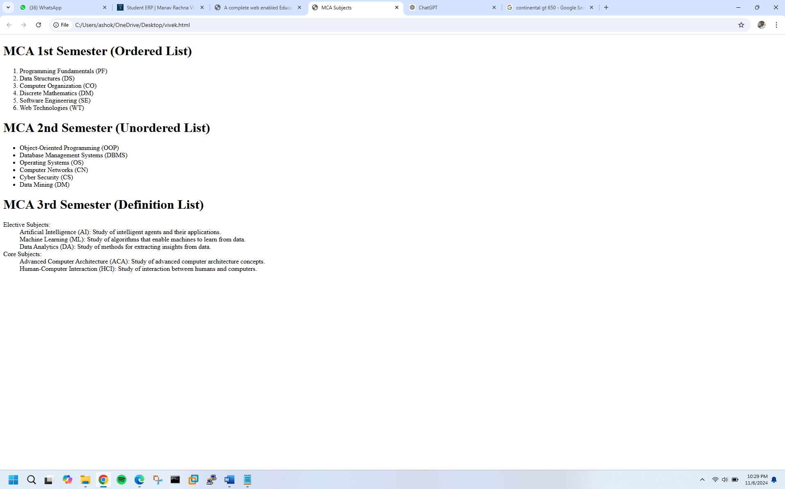

**EXERCISE NO.16**

**QUES-16 WRITE HTML CODE USING <FRAMESET> AND <FRAME> TAG WITH ALL ITS ATTRIBUTES?**

**CODE:**

**<!DOCTYPE html>**

**<html>**

**<head>**

**<title>Frameset Example</title>**

**</head>**

**<frameset rows="20%, 80%">**

**<frame src="header.html" name="header" frameborder="0" scrolling="no" noresize>**

**<frameset cols="30%, 70%">**

**<frame src="menu.html" name="menu" frameborder="0" scrolling="auto">**

**<frame src="content.html" name="content" frameborder="0" scrolling="auto">**

**</frameset>**

**</frameset>**

**</html>**

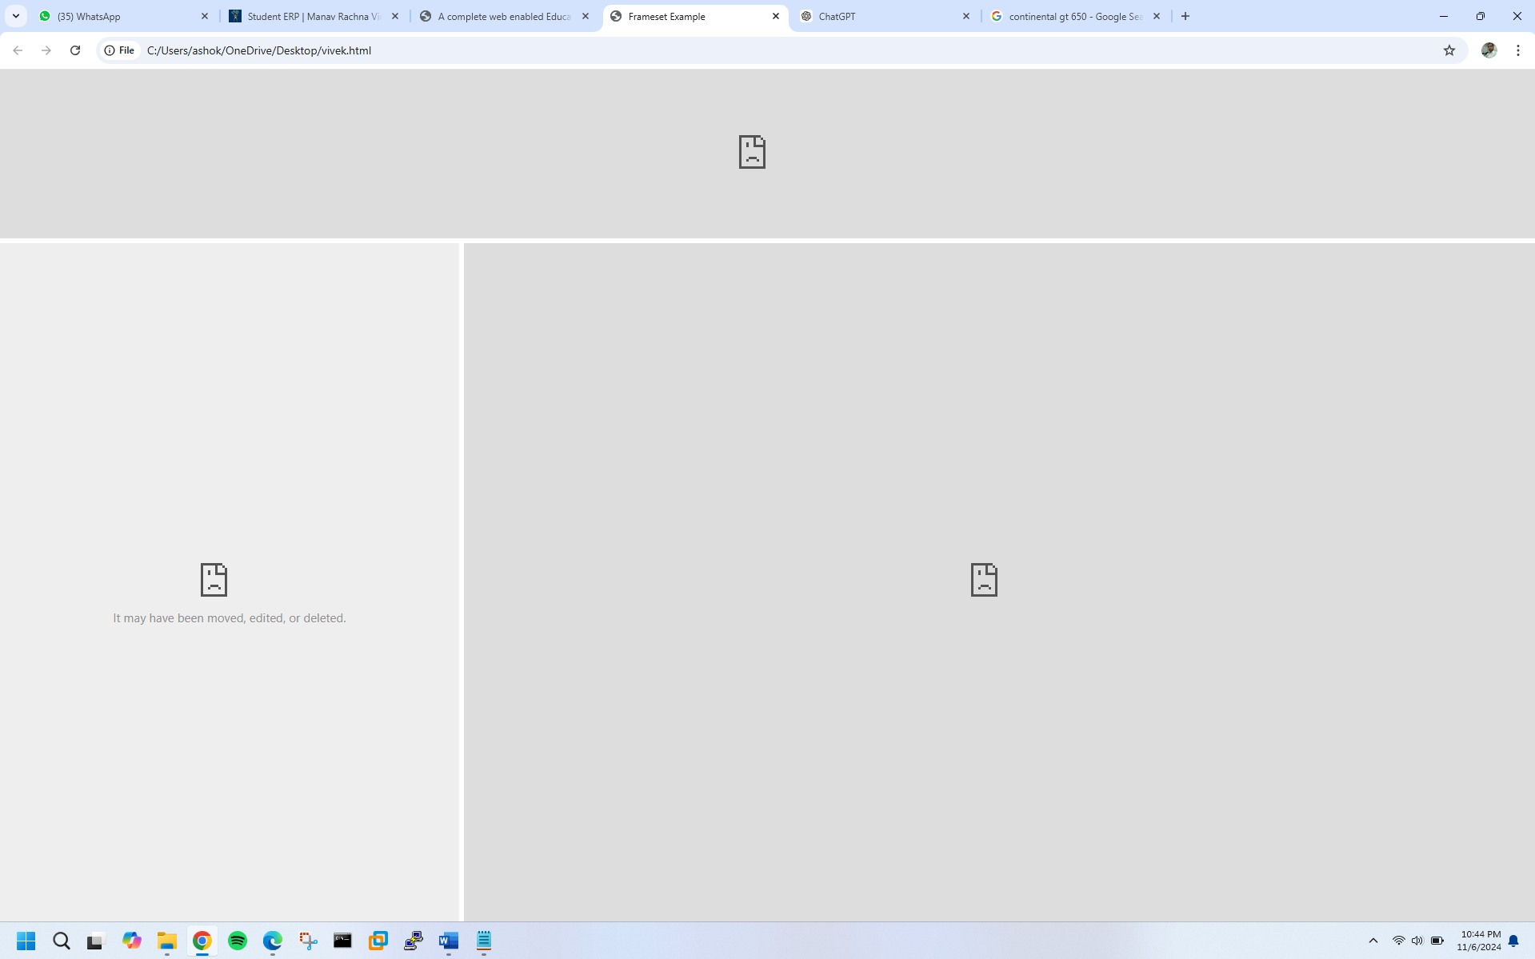

**EXERCISE NO.17**

**QUES-17 WRITE HTML CODE TO DESIGN A FORM IN HTML USING CONTROLS AND BUTTONS SUCH AS TEXTBOX, TEXT AREA, PASSWORD, SUBMIT BUTTON, BROWSE BUTTON, DROP-DOWN MENU?**

**CODE:**

**<!DOCTYPE html>**

**<html>**

**<head>**

**<title>Registration Form</title>**

**<style>**

**body {**

**font-family: Arial, sans-serif;**

**}**

**form {**

**width: 50%;**

**margin: 40px auto;**

**padding: 20px;**

**border: 1px solid #ccc;**

**border-radius: 10px;**

**box-shadow: 0 0 10px rgba(0, 0, 0, 0.1);**

**}**

**label {**

**display: block;**

**margin-bottom: 10px;**

**}**

**input[type="text"], input[type="password"], select {**

**width: 100%;**

**height: 40px;**

**margin-bottom: 20px;**

**padding: 10px;**

**border: 1px solid #ccc;**

**}**

**textarea {**

**width: 100%;**

**height: 100px;**

**margin-bottom: 20px;**

**padding: 10px;**

**border: 1px solid #ccc;**

**}**

**input[type="submit"], input[type="reset"] {**

**width: 100%;**

**height: 40px;**

**background-color: #4CAF50;**

**color: #fff;**

**padding: 10px;**

**border: none;**

**border-radius: 5px;**

**cursor: pointer;**

**}**

**input[type="submit"]:hover, input[type="reset"]:hover {**

**background-color: #3e8e41;**

**}**

**</style>**

**</head>**

**<body>**

**<h1>Registration Form</h1>**

**<form>**

**<label for="name">Name:</label>**

**<input type="text" id="name" placeholder="Enter your name">**

**<label for="email">Email:</label>**

**<input type="text" id="email" placeholder="Enter your email">**

**<label for="password">Password:</label>**

**<input type="password" id="password" placeholder="Enter your password">**

**<label for="address">Address:</label>**

**<textarea id="address" placeholder="Enter your address"></textarea>**

**<label for="country">Country:</label>**

**<select id="country">**

**<option value="">Select your country</option>**

**<option value="USA">USA</option>**

**<option value="Canada">Canada</option>**

**<option value="UK">UK</option>**

**</select>**

**<label for="profile">Profile Picture:</label>**

**<input type="file" id="profile">**

**<input type="submit" value="Register">**

**<input type="reset" value="Reset">**

**</form>**

**</body>**

**</html>**

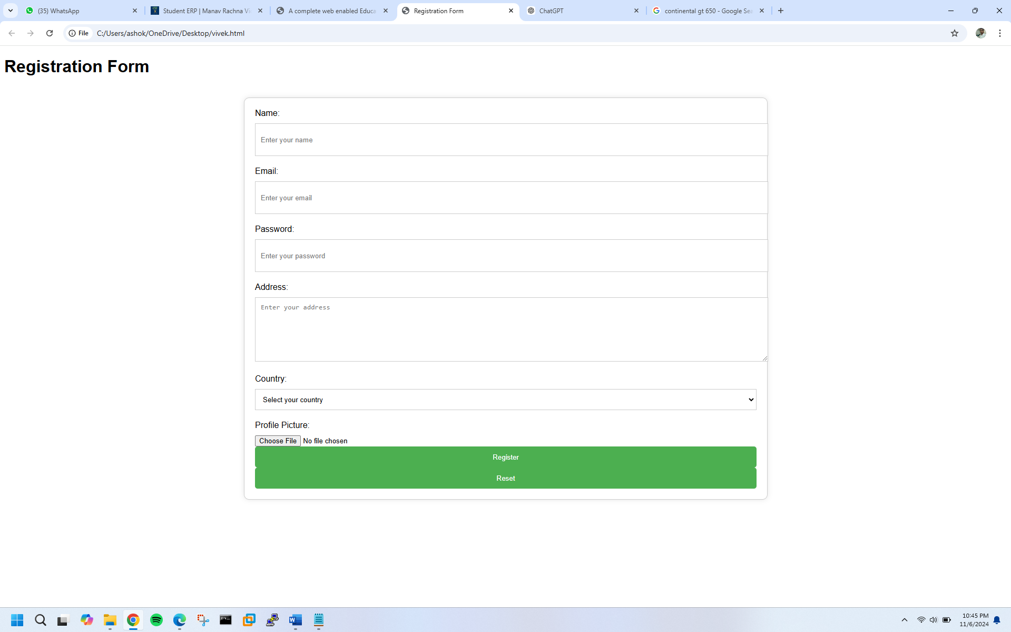

**EXERCISE NO.18**

**QUES-18 WRITE HTML CODE TO DESIGN A REGISTRATION FORM IN HTML?**

**CODE:**

**<!DOCTYPE html>**

**<html>**

**<head>**

**<title>Registration Form</title>**

**<style>**

**body {**

**font-family: Arial, sans-serif;**

**background-color: #f2f2f2;**

**}**

**.form-container {**

**width: 300px;**

**margin: 50px auto;**

**padding: 20px;**

**background-color: #fff;**

**border: 1px solid #ddd;**

**border-radius: 10px;**

**box-shadow: 0 0 10px rgba(0, 0, 0, 0.1);**

**}**

**.form-title {**

**text-align: center;**

**margin-bottom: 20px;**

**}**

**.form-label {**

**display: block;**

**margin-bottom: 10px;**

**}**

**.form-input {**

**width: 100%;**

**height: 40px;**

**margin-bottom: 20px;**

**padding: 10px;**

**border: 1px solid #ccc;**

**}**

**.form-button {**

**width: 100%;**

**height: 40px;**

**background-color: #4CAF50;**

**color: #fff;**

**padding: 10px;**

**border: none;**

**border-radius: 5px;**

**cursor: pointer;**

**}**

**.form-button:hover {**

**background-color: #3e8e41;**

**}**

**</style>**

**</head>**

**<body>**

**<div class="form-container">**

**<h2 class="form-title">Registration Form</h2>**

**<form>**

**<label class="form-label" for="fname">First Name:</label>**

**<input class="form-input" type="text" id="fname" placeholder="Enter first name">**

**<label class="form-label" for="lname">Last Name:</label>**

**<input class="form-input" type="text" id="lname" placeholder="Enter last name">**

**<label class="form-label" for="email">Email:</label>**

**<input class="form-input" type="email" id="email" placeholder="Enter email">**

**<label class="form-label" for="password">Password:</label>**

**<input class="form-input" type="password" id="password" placeholder="Enter password">**

**<label class="form-label" for="confirm-password">Confirm Password:</label>**

**<input class="form-input" type="password" id="confirm-password" placeholder="Enter confirm password">**

**<label class="form-label" for="phone">Phone Number:</label>**

**<input class="form-input" type="tel" id="phone" placeholder="Enter phone number">**

**<label class="form-label" for="address">Address:</label>**

**<textarea class="form-input" id="address" placeholder="Enter address"></textarea>**

**<input class="form-button" type="submit" value="Register">**

**</form>**

**</div>**

**</body>**

**</html>**

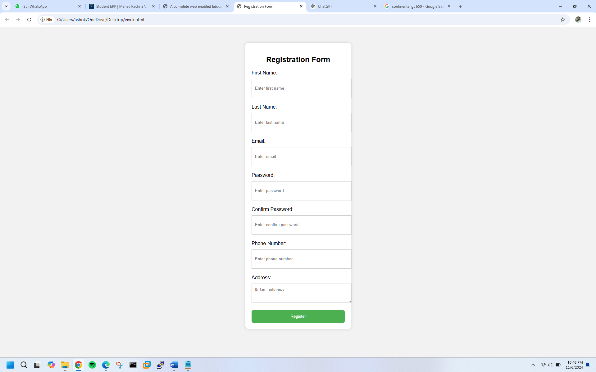

**EXERCISE N0.19**

QUES-19 WRITE HTML CODE TO DESIGN A STUDENT ADMISSION FORM IN HTML?

**CODE:**

**Here's an example HTML code to design a student admission form:**

**<!DOCTYPE html>**

**<html>**

**<head>**

**<title>Student Admission Form</title>**

**<style>**

**body {**

**font-family: Arial, sans-serif;**

**background-color: #f2f2f2;**

**}**

**.form-container {**

**width: 600px;**

**margin: 50px auto;**

**padding: 20px;**

**background-color: #fff;**

**border: 1px solid #ddd;**

**border-radius: 10px;**

**box-shadow: 0 0 10px rgba(0, 0, 0, 0.1);**

**}**

**.form-title {**

**text-align: center;**

**margin-bottom: 20px;**

**}**

**.form-label {**

**display: block;**

**margin-bottom: 10px;**

**}**

**.form-input {**

**width: 100%;**

**height: 40px;**

**margin-bottom: 20px;**

**padding: 10px;**

**border: 1px solid #ccc;**

**}**

**.form-button {**

**width: 100%;**

**height: 40px;**

**background-color: #4CAF50;**

**color: #fff;**

**padding: 10px;**

**border: none;**

**border-radius: 5px;**

**cursor: pointer;**

**}**

**.form-button:hover {**

**background-color: #3e8e41;**

**}**

**</style>**

**</head>**

**<body>**

**<div class="form-container">**

**<h2 class="form-title">Student Admission Form</h2>**

**<form>**

**<!-- Student Information -->**

**<h3>Student Information:</h3>**

**<label class="form-label" for="name">Name:</label>**

**<input class="form-input" type="text" id="name" placeholder="Enter name">**

**<label class="form-label" for="dateOfBirth">Date of Birth:</label>**

**<input class="form-input" type="date" id="dateOfBirth" placeholder="Enter date of birth">**

**<label class="form-label" for="gender">Gender:</label>**

**<select class="form-input" id="gender">**

**<option value="">Select gender</option>**

**<option value="male">Male</option>**

**<option value="female">Female</option>**

**<option value="other">Other</option>**

**</select>**

**<!-- Parent Information -->**

**<h3>Parent Information:</h3>**

**<label class="form-label" for="fatherName">Father's Name:</label>**

**<input class="form-input" type="text" id="fatherName" placeholder="Enter father's name">**

**<label class="form-label" for="motherName">Mother's Name:</label>**

**<input class="form-input" type="text" id="motherName" placeholder="Enter mother's name">**

**<label class="form-label" for="parentContact">Parent Contact:</label>**

**<input class="form-input" type="tel" id="parentContact" placeholder="Enter parent contact">**

**<!-- Educational Information -->**

**<h3>Educational Information:</h3>**

**<label class="form-label" for="course">Course:</label>**

**<select class="form-input" id="course">**

**<option value="">Select course</option>**

**<option value="BCA">BCA</option>**

**<option value="B.Tech">B.Tech</option>**

**<option value="MCA">MCA</option>**

**<option value="M.Tech">M.Tech</option>**

**</select>**

**<label class="form-label" for="semester">Semester:</label>**

**<select class="form-input" id="semester">**

**<option value="">Select semester</option>**

**<option value="1st">1st</option>**

**<option value="2nd">2nd</option>**

**<option value="3rd">3rd</option>**

**<option value="4th">4th</option>**

**<option value="5th">5th</option>**

**<option value="6th">6th</option>**

**</select>**

**<!-- Address -->**

**<h3>Address:</h3>**

**<label class="form-label" for="address">Address:</label>**

**<textarea class="form-input" id="address" placeholder="Enter address"></textarea>**

**<!-- Submit Button -->**

**<input class="form-button" type="submit" value="Submit">**

**</form>**

**</div>**

**</body>**

**</html>**

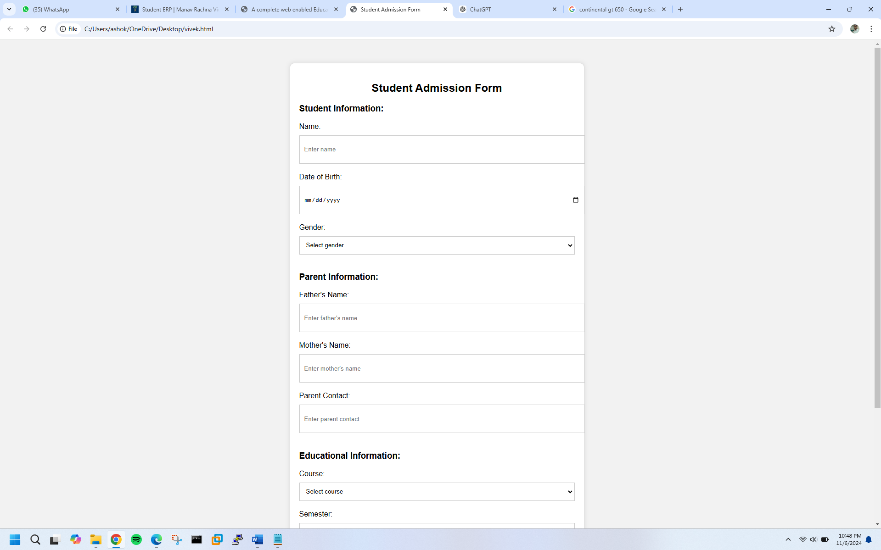

**EXERCISE N0.20**

Create a proper home page of your own using any components and styles.

<!DOCTYPE html>

<html lang="en">

<head>

<meta charset="UTF-8">

<meta name="viewport" content="width=device-width, initial-scale=1.0">

<title>Meta AI Home</title>

<link rel="stylesheet" href="styles.css">

</head>

<body>

<!-- Header Section -->

<header>

<nav>

<ul>

<li><a href="#home">Home</a></li>

<li><a href="#about">About</a></li>

<li><a href="#contact">Contact</a></li>

</ul>

</nav>

</header>

<!-- Hero Section -->

<section id="home">

<h1>Welcome to Meta AI Home</h1>

<p>Explore the world of AI and beyond!</p>

<button>Learn More</button>

</section>

<!-- About Section -->

<section id="about">

<h2>About Us</h2>

<p>We're passionate about AI and its applications.</p>

<img src="ai-image.jpg" alt="AI Image">

</section>

<!-- Contact Section -->

<section id="contact">

<h2>Get in Touch</h2>

<form>

<input type="text" placeholder="Name">

<input type="email" placeholder="Email">

<textarea placeholder="Message"></textarea>

<button>Send</button>

</form>

</section>

<!-- Footer Section -->

<footer>

<p>&copy; 2024 Meta AI Home</p>

</footer>

<script src="script.js"></script>

</body>

</html>

styles.css

body {

font-family: Arial, sans-serif;

margin: 0;

padding: 0;

}

header {

background-color: #333;

color: #fff;

padding: 1em;

text-align: center;

}

nav ul {

list-style: none;

margin: 0;

padding: 0;

display: flex;

justify-content: space-between;

}

nav li {

margin-right: 20px;

}

nav a {

color: #fff;

text-decoration: none;

}

#home {

background-image: linear-gradient(to bottom, #f7f7f7, #fff);

padding: 5em;

text-align: center;

}

#about {

background-color: #f7f7f7;

padding: 3em;

}

#about img {

width: 50%;

height: auto;

margin: 20px auto;

}

#contact {

background-color: #fff;

padding: 3em;

}

form {

display: flex;

flex-direction: column;

align-items: center;

}

input, textarea {

width: 100%;

padding: 10px;

margin-bottom: 20px;

border: 1px solid #ccc;

}

button {

background-color: #333;

color: #fff;

border: none;

padding: 10px 20px;

cursor: pointer;

}

footer {

background-color: #333;

color: #fff;

padding: 1em;

text-align: center;

clear: both;

}

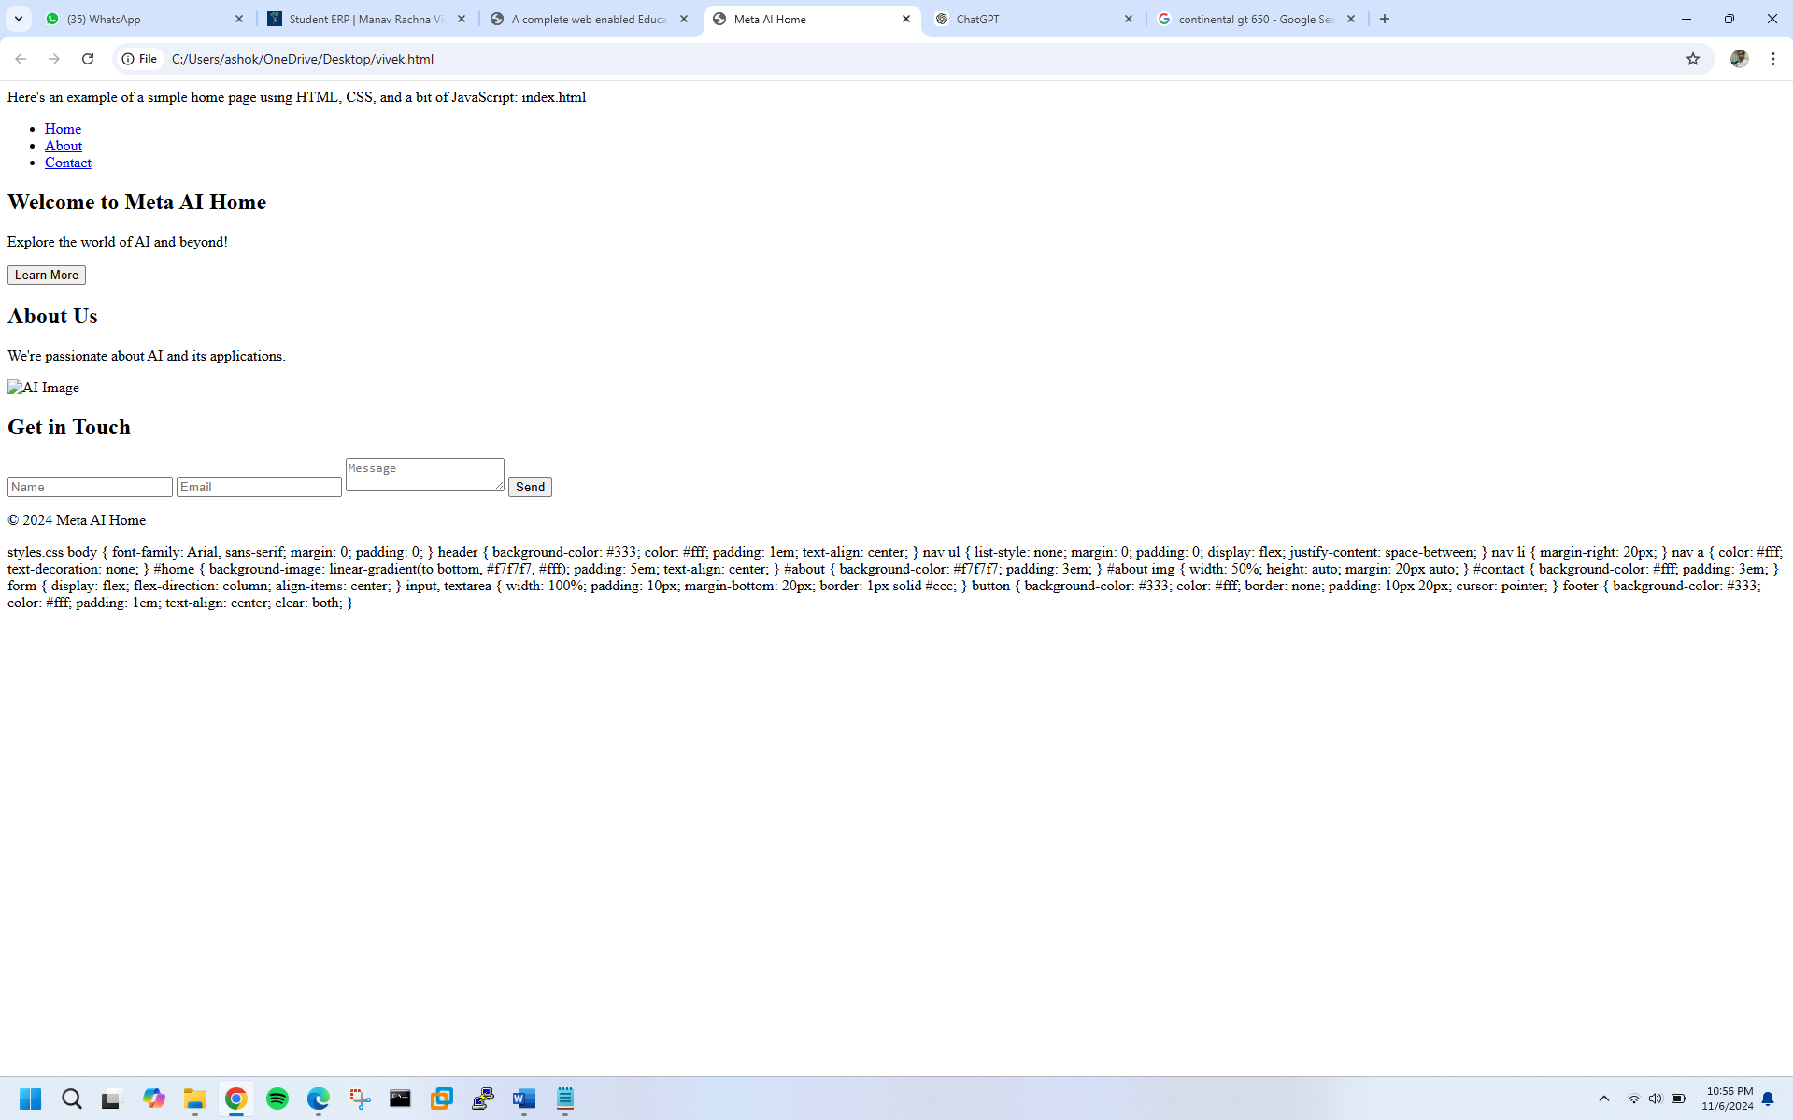

**EXERCISE N0.21**

Write HTML code for including Local hyperlinking in a web page.

<!DOCTYPE html>

<html>

<head>

<title>Local Hyperlinking Example</title>

</head>

<body>

<!-- Creating a hyperlink to a section within the same page -->

<a href="#top">Go to Top</a> |

<a href="#middle">Go to Middle</a> |

<a href="#bottom">Go to Bottom</a>

<!-- Content -->

<p>Lorem ipsum dolor sit amet, consectetur adipiscing elit. Sed sit amet nulla auctor, vestibulum magna sed, convallis ex.</p>

<p>Lorem ipsum dolor sit amet, consectetur adipiscing elit. Sed sit amet nulla auctor, vestibulum magna sed, convallis ex.</p>

<!-- Anchor tag with id attribute for "Top" section -->

<h2 id="top">Top Section</h2>

<p>Lorem ipsum dolor sit amet, consectetur adipiscing elit. Sed sit amet nulla auctor, vestibulum magna sed, convallis ex.</p>

<p>Lorem ipsum dolor sit amet, consectetur adipiscing elit. Sed sit amet nulla auctor, vestibulum magna sed, convallis ex.</p>

<!-- More content -->

<p>Lorem ipsum dolor sit amet, consectetur adipiscing elit. Sed sit amet nulla auctor, vestibulum magna sed, convallis ex.</p>

<p>Lorem ipsum dolor sit amet, consectetur adipiscing elit. Sed sit amet nulla auctor, vestibulum magna sed, convallis ex.</p>

<!-- Anchor tag with id attribute for "Middle" section -->

<h2 id="middle">Middle Section</h2>

<p>Lorem ipsum dolor sit amet, consectetur adipiscing elit. Sed sit amet nulla auctor, vestibulum magna sed, convallis ex.</p>

<p>Lorem ipsum dolor sit amet, consectetur adipiscing elit. Sed sit amet nulla auctor, vestibulum magna sed, convallis ex.</p>

<!-- More content -->

<p>Lorem ipsum dolor sit amet, consectetur adipiscing elit. Sed sit amet nulla auctor, vestibulum magna sed, convallis ex.</p>

<p>Lorem ipsum dolor sit amet, consectetur adipiscing elit. Sed sit amet nulla auctor, vestibulum magna sed, convallis ex.</p>

<!-- Anchor tag with id attribute for "Bottom" section -->

<h2 id="bottom">Bottom Section</h2>

<p>Lorem ipsum dolor sit amet, consectetur adipiscing elit. Sed sit amet nulla auctor, vestibulum magna sed, convallis ex.</p>

<p>Lorem ipsum dolor sit amet, consectetur adipiscing elit. Sed sit amet nulla auctor, vestibulum magna sed, convallis ex.</p>

</body>

</html>

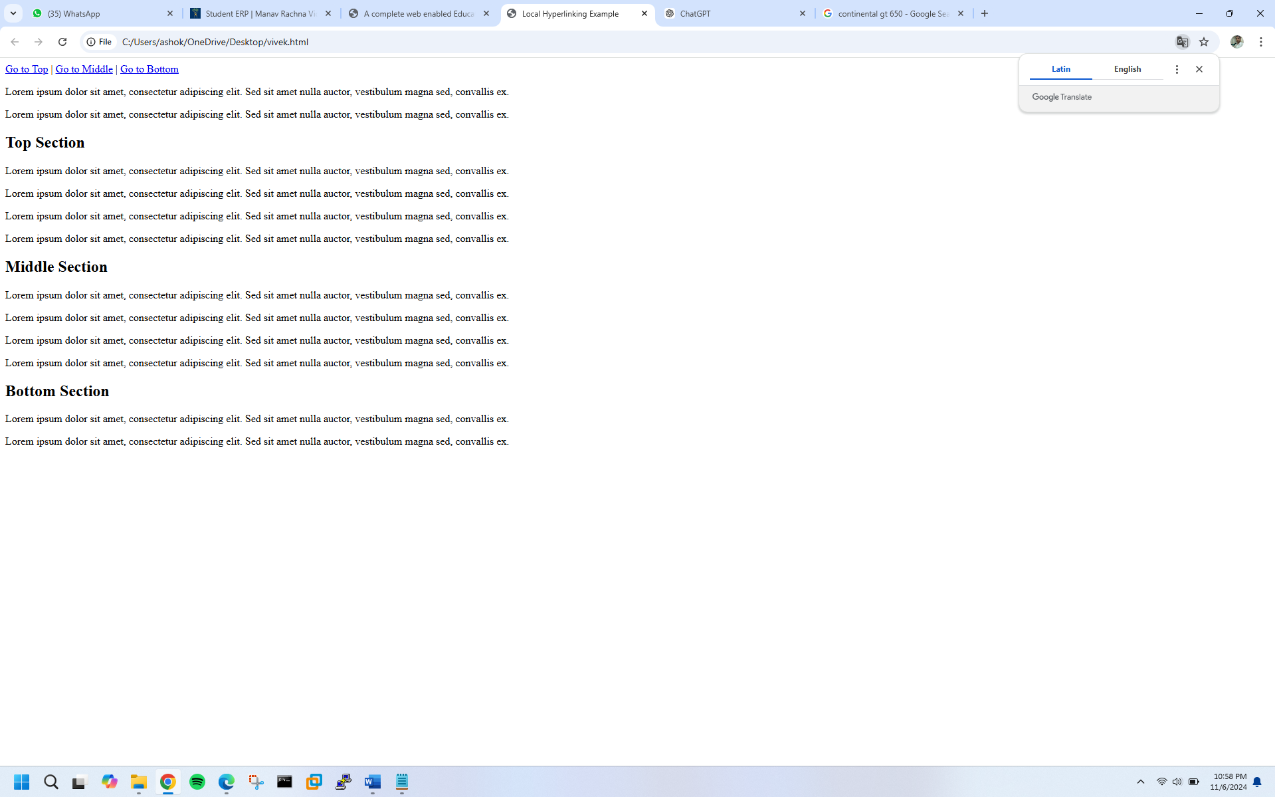

**EXERCISE N0.22**

Write HTML code for including Inter hyperlinking in a web page.

<!DOCTYPE html>

<html>

<head>

<title>Inter Hyperlinking Example</title>

</head>

<body>

<!-- Creating hyperlinks to external web pages -->

<a href="(link unavailable)">Visit Google</a><br>

<a href="(link unavailable)">Visit Facebook</a><br>

<a href="(link unavailable)">Visit Twitter</a><br>

<!-- Target attribute to open link in new tab or window -->

<a href="(link unavailable)" target="_blank">Visit Wikipedia (New Tab)</a><br>

<a href="(link unavailable)" target="_self">Visit GitHub (Same Window)</a><br>

<!-- Title attribute for tooltip text -->

<a href="(link unavailable)" title="Q&A Platform for Developers">Visit Stack Overflow</a><br>

<!-- Email hyperlink -->

<a href="mailto:example@example.com">Email Us</a><br>

</body>

</html>

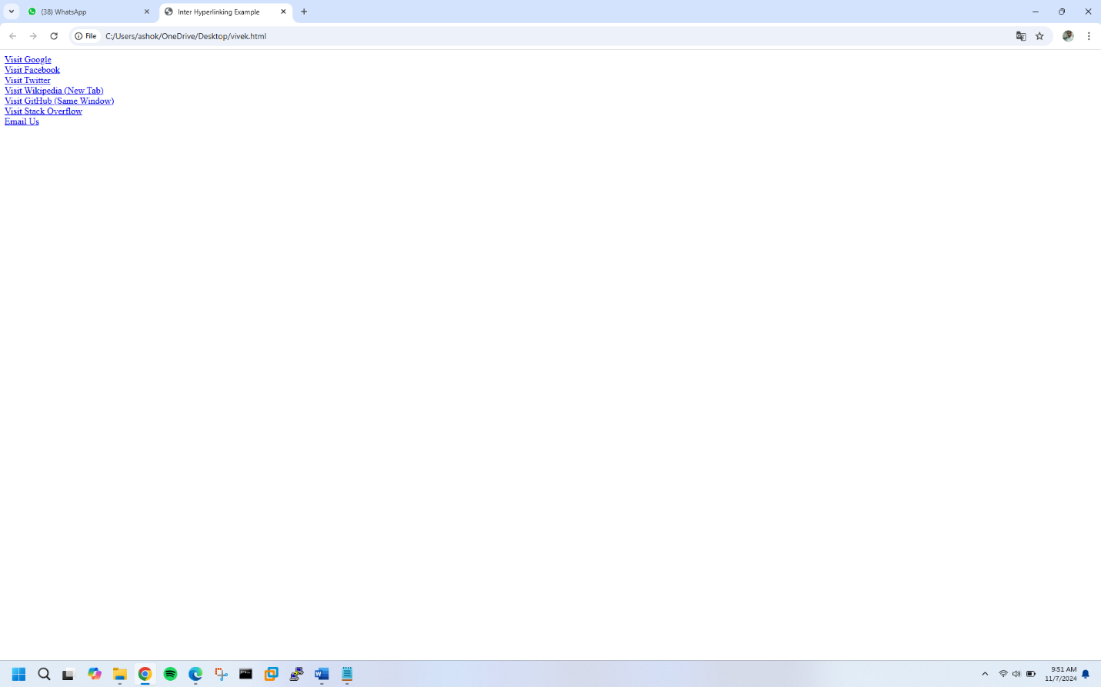

**EXERCISE N0.23**

Write HTML code for including External hyperlinking in a web page.

<!DOCTYPE html>

<html>

<head>

<title>External Hyperlinking Example</title>

</head>

<body>

<!-- External Hyperlink with HTTP protocol -->

<a href="(link unavailable)">Visit Google</a><br>

<!-- External Hyperlink with HTTPS protocol -->

<a href="(link unavailable)">Visit Facebook</a><br>

<!-- External Hyperlink with Target Attribute -->

<a href="(link unavailable)" target="_blank">Visit Twitter (New Tab)</a><br>

<!-- External Hyperlink with Title Attribute -->

<a href="(link unavailable)" title="Free Online Encyclopedia">Visit Wikipedia</a><br>

<!-- External Hyperlink with Image -->

<a href="(link unavailable)"><img src="github-logo.png" alt="GitHub Logo"></a><br>

<!-- External Hyperlink with Email -->

<a href="mailto:info@example.com">Email Us</a><br>

<!-- External Hyperlink with Phone Number -->

<a href="tel:+1234567890">Call Us</a><br>

</body>

</html>

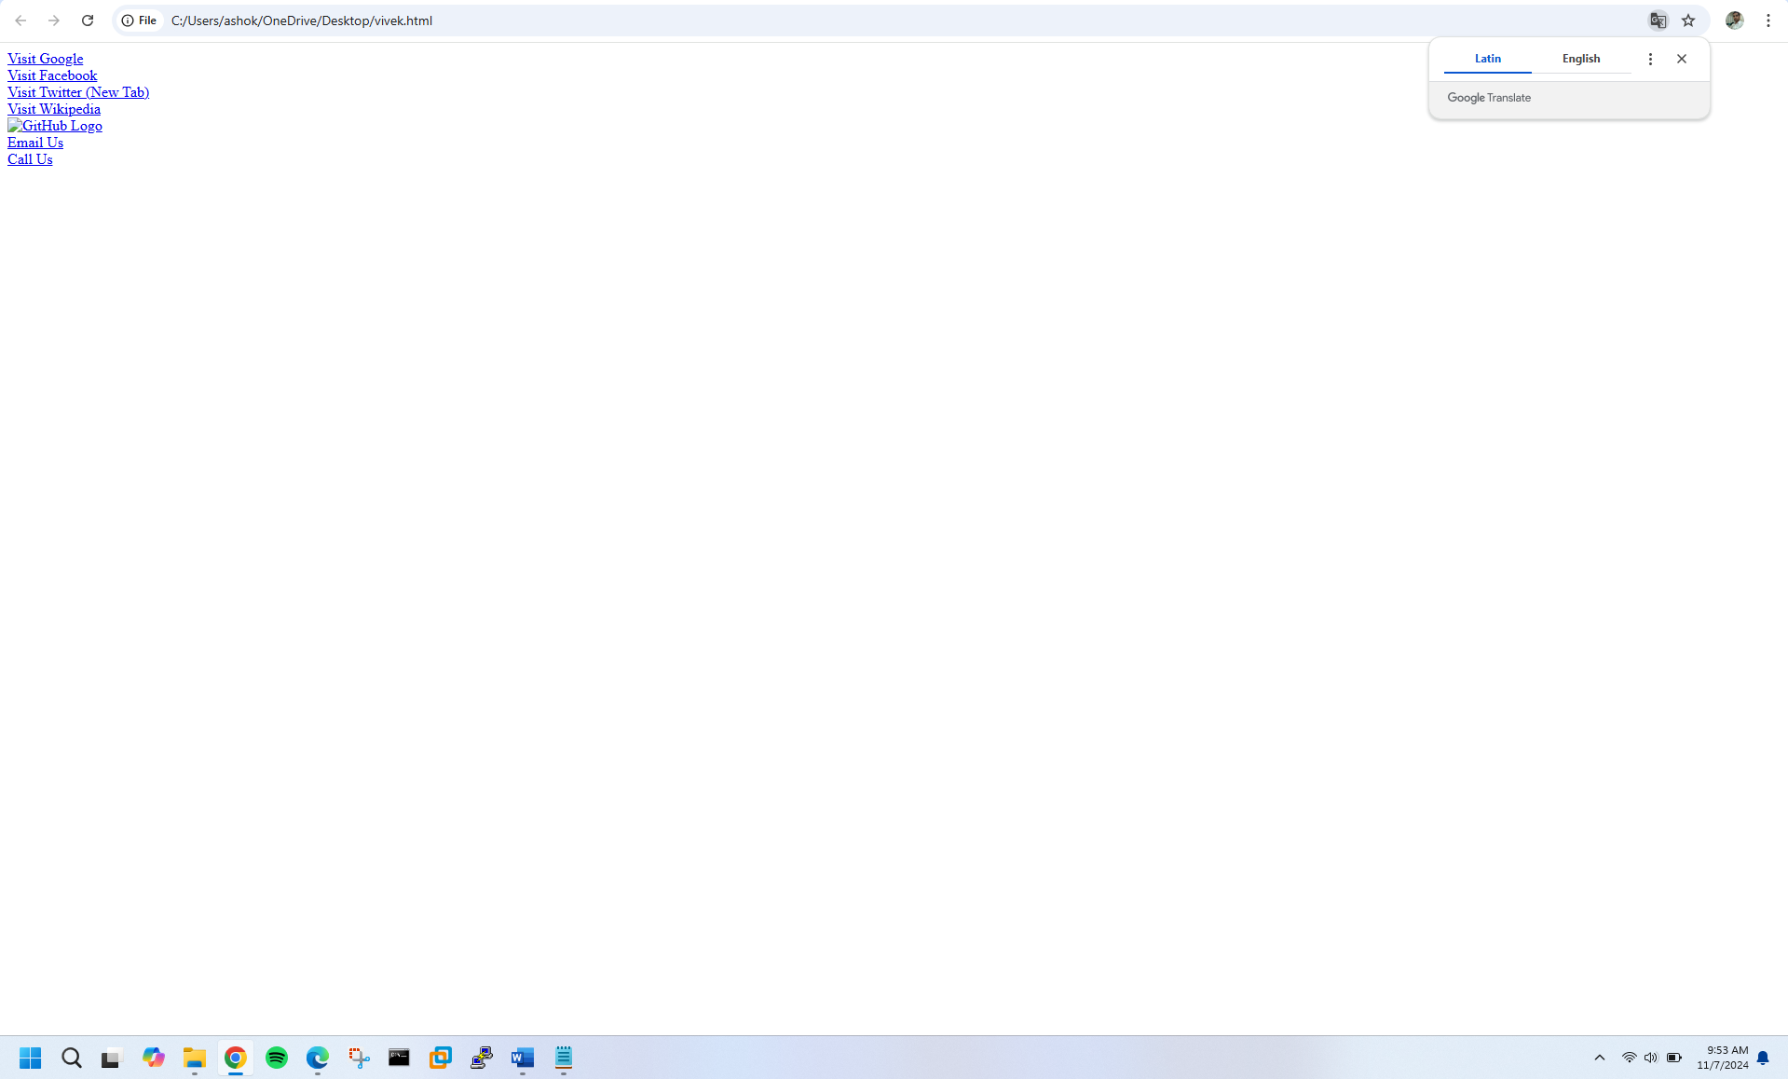

**EXERCISE N0.24**

Write code to show External CSS with HTML code

<!DOCTYPE html>

<html>

<head>

<title>External CSS Example</title>

<link rel="stylesheet" type="text/css" href="styles.css">

</head>

<body>

<h1>Welcome to External CSS Example</h1>

<p>This paragraph will be styled by external CSS.</p>

<a href="(link unavailable)">Visit Google</a>

</body>

</html>

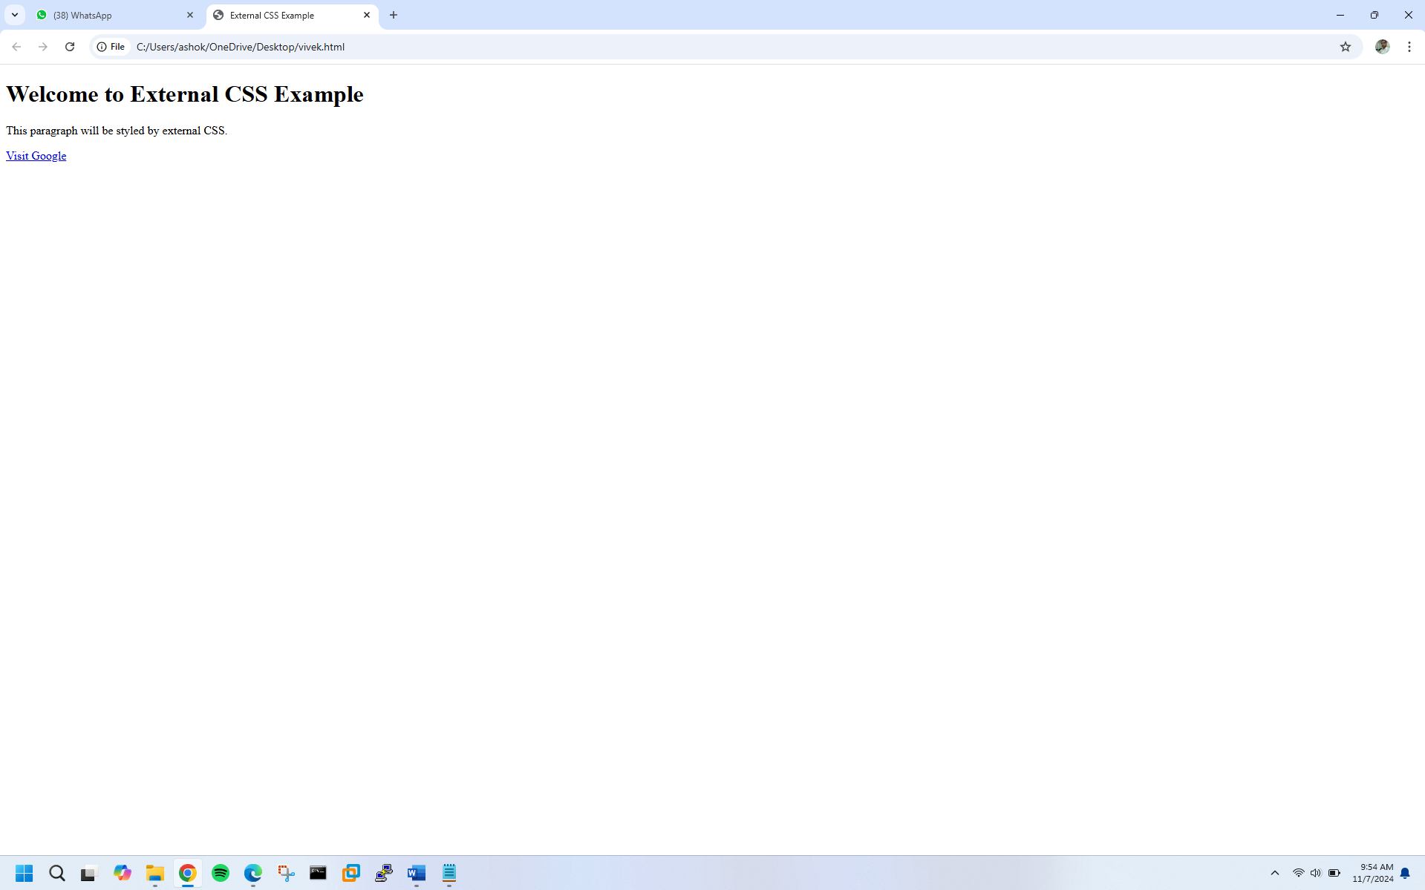

**EXERCISE N0.25**

Write code to show Internal CSS with HTML code.

<!DOCTYPE html>

<html>

<head>

<title>Internal CSS Example</title>

<style>

/* Internal CSS styles */

body {

background-color: #f2f2f2;

font-family: Arial, sans-serif;

}

h1 {

color: #00698f;

text-align: center;

}

p {

font-size: 18px;

color: #666;

margin-bottom: 20px;

}

a {

text-decoration: none;

color: #0096c7;

}

a:hover {

color: #007bff;

}

</style>

</head>

<body>

<h1>Welcome to Internal CSS Example</h1>

<p>This paragraph will be styled by internal CSS.</p>

<a href="(link unavailable)">Visit Google</a>

</body>

</html>

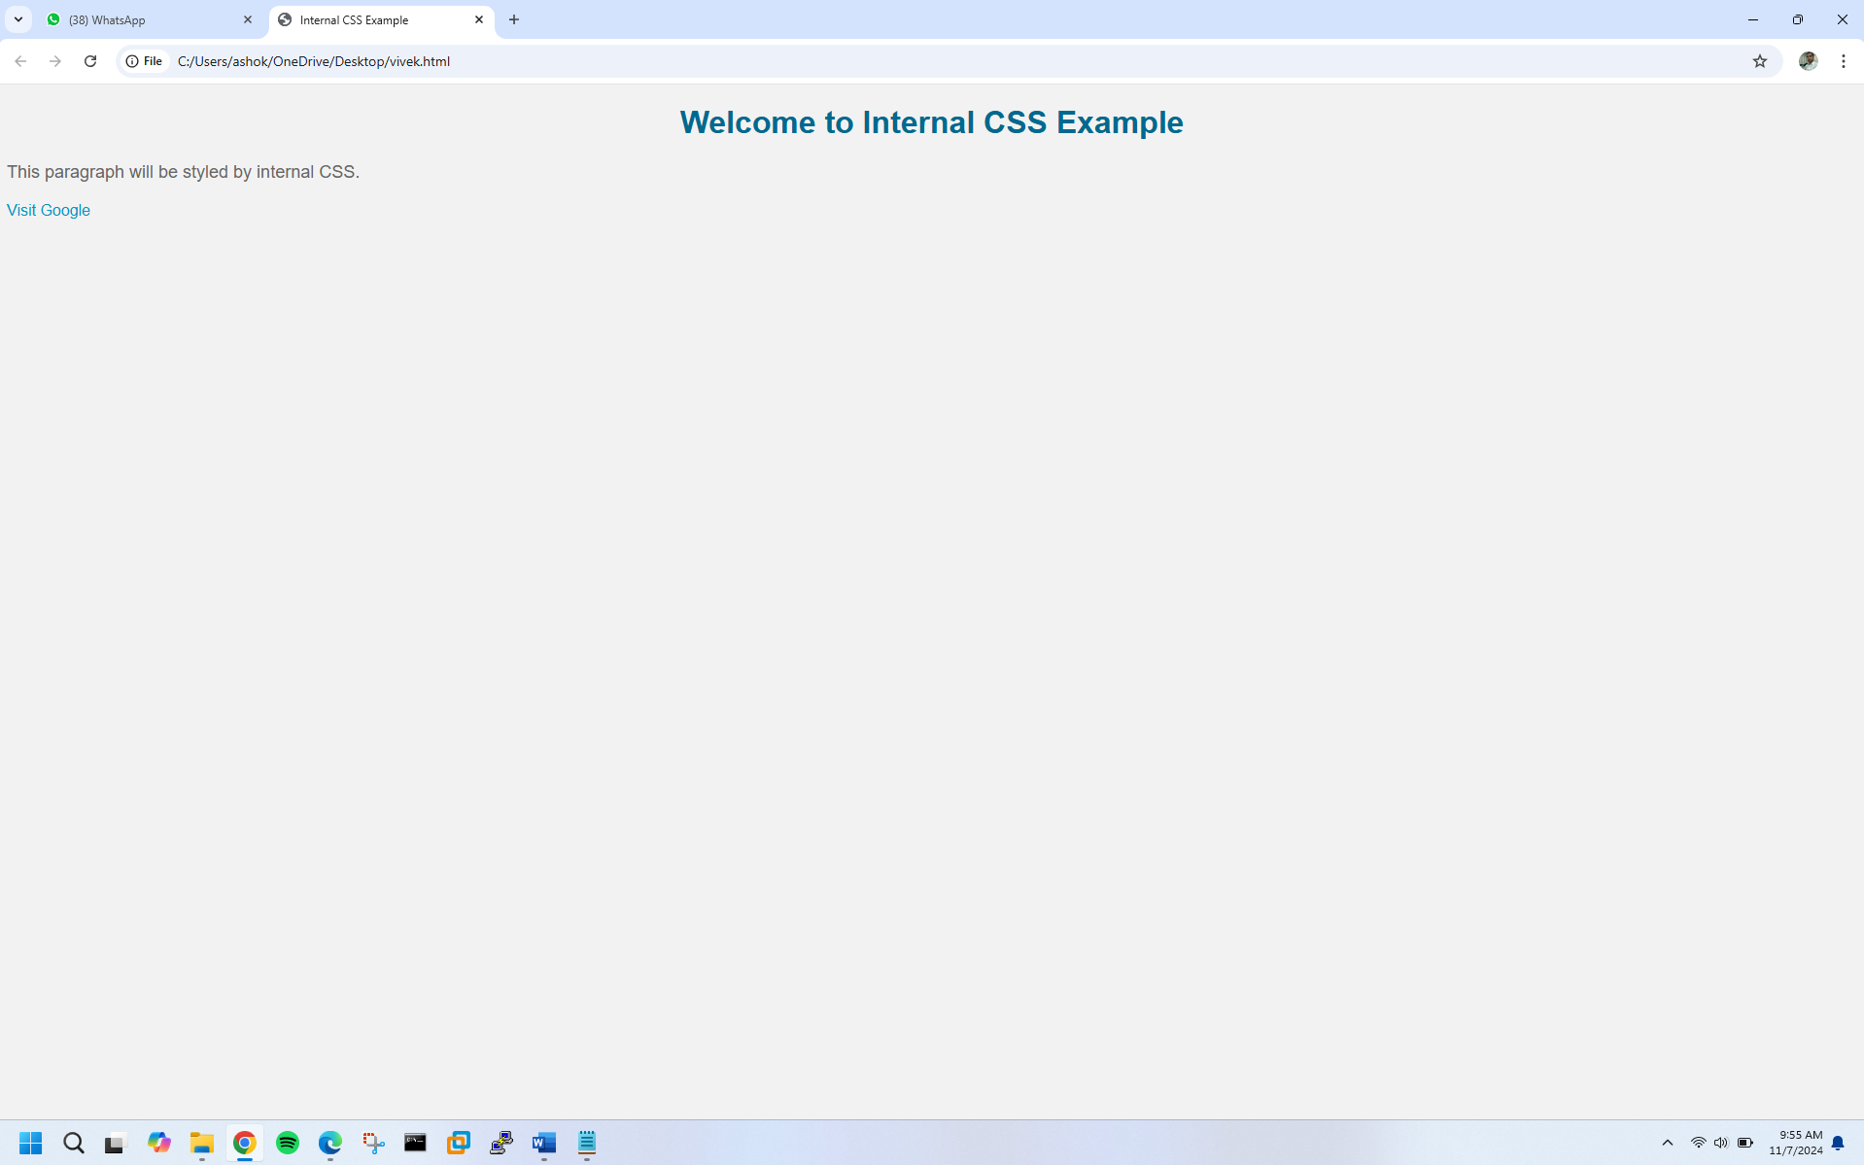

**EXERCISE N0.26**

Write code to show Inline CSS with HTML code.

<!DOCTYPE html>

<html>

<head>

<title>Inline CSS Example</title>

</head>

<body>

<!-- Inline CSS for h1 -->

<h1 style="color: #00698f; text-align: center;">Welcome to Inline CSS Example</h1>

<!-- Inline CSS for paragraph -->

<p style="font-size: 18px; color: #666; margin-bottom: 20px;">This paragraph will be styled by inline CSS.</p>

<!-- Inline CSS for link -->

<a href="(link unavailable)" style="text-decoration: none; color: #0096c7;">Visit Google</a>

<!-- Inline CSS for div -->

<div style="background-color: #f2f2f2; padding: 20px; border: 1px solid #ccc;">

<h2 style="color: #333;">Inline CSS Div</h2>

<p style="font-size: 16px;">This div will be styled by inline CSS.</p>

</div>

</body>

</html>

